**PyCity Schools Analysis**

After looking at the data, it shows Charter schools are outperforming the District schools. The data also indicates there is not a direct correlation to the amount of dollars spent per student and the school being a top performer. In fact, schools with lower dollars performed better. Smaller schools also performed better.

District Summary



School Summary

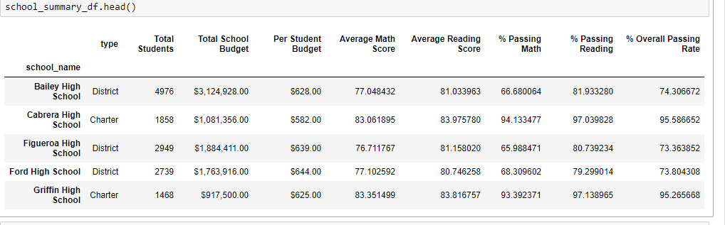

Top Performing Schools (By Passing Rate)

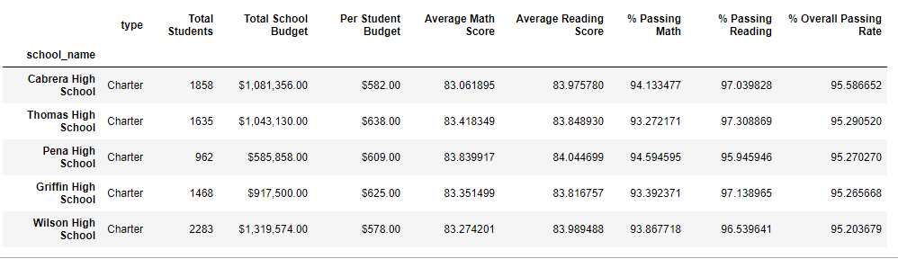

Bottom Performing Schools (By Passing Rate)

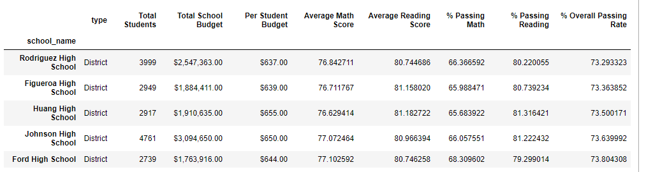

## Math Scores by Grade

## 

Reading Scores by Grade

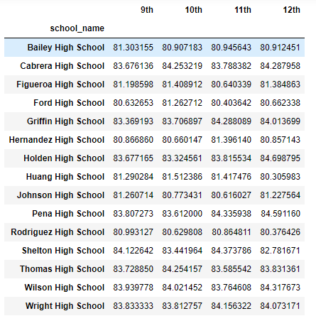

## Scores by School Spending

## 

Scores by School Size

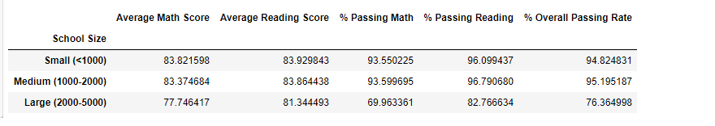

Scores by School Type

